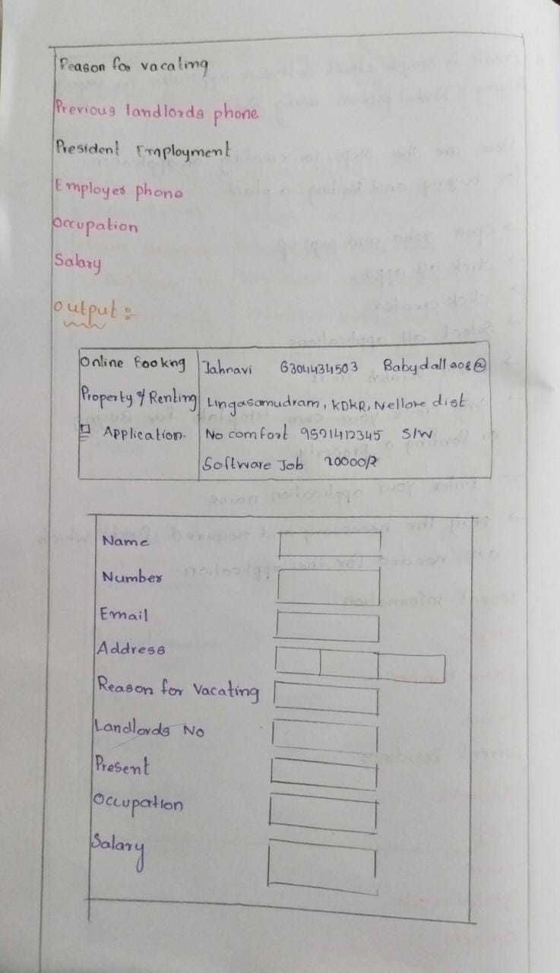Create a simple cloud software application for Property Buying & Rental process (In Chennai city) using any Cloud Service Provider to demonstrate SaaS

